The Urban Energy Context of Dar es Salaam, Tanzania

Alicia Noriega, Jose Domingo Soto Rivera, Philip Eash-Gates

Massachusetts Institute of Technology: 11.165 Urban Energy Systems & Policy

Table of Contents

Table of Contents 2

The Urban Energy Context of Dar es Salaam, Tanzania 4

Demographics and Climate Trends 4

Informal settlements 5

Electricity Theft 5

Energy for Doing Business 7

Residential Consumers 8

Energy Development for Economic Growth 8

Climate Trends 10

Regulatory Environment 10

Energy Supply 12

Generation 12

Biomass 13

Biofuels 14

Solar 15

Wind 16

Natural Gas 17

Hydropower 18

Liquid Fuel & EPP’s 18

Transmission/ Distribution 19

Small Power Projects-Minigrid 20

Energy End Uses 22

Transportation 23

Private Transport 25

Public Transport 25

Goods Transport 26

Buildings 27

Food Preparation 28

Lighting 29

Space Heating, Cooling, and Ventilation 29

Appliances & plug load 30

Industry and Manufacturing 30

Agriculture 31

Crops 31

Livestock 32

Conclusion 32

References 35

Appendix A: Supplemental Data and Energy Calculations 38

The Urban Energy Context of Dar es Salaam, Tanzania

Tanzania ranks among the top ten countries in the world for electricity access deficit, preceded in magnitude only by India and marginally by a few other countries[1]. Energy access has explicit and implicit implications for future city growth and economic development. For instance, in 2013 the World Bank Enterprise Surveys showed that power outages in Tanzania cost businesses about 15 percent of annual sales [1]. Since 2013, population in Dar es Salaam has grown exponentially in size, and the country’s main source of power, hydroelectric plants, are increasingly compromised due to droughts. Residents in the urban capital of Dar es Salaam are acclimated to the reality of making do with less energy access and infrastructure – there are bus systems that prioritize packing people in over space or comfort, a growing informal edge gathering fuel resources from surrounding wooded areas, and a utility (TANESCO) slowly but surely opening its doors for more private investment and distributed generation. Tanzania’s government has committed to doubling its electricity production over the next four years [2], largely through the exploitation of massive natural gas resources, however, the abundance of sunshine conducive to the development of on- and off-grid solar is also being examined closely by the government, donors, and private developers.

# Demographics and Climate Trends

Dar es Salaam is outpacing its peers in terms of rate of growth over time, as illustrated by Figure 11 in the Appendix. The population is forecast to grow from 4 million presently to 5 million by 2020, and 21 million by 2050. Dar es Salaam is likely to achieve '[megacity](http://www.un.org/esa/population/publications/WUP2005/2005WUP_FS7.pdf)' status (10 million residents or more) by the early 2030s according to some sources, meaning that energy demand will likely spike dramatically. In 2014, the rate of electricity access in urban centers of Tanzania was 42%, as reported by the World Bank [3]. In recent years, Tanzania has sustained steady economic growth at approximately 7% per annum. The rapid rate of urban population and economic growth has strained the existing infrastructure, including the electricity grid, roads, and bus system [4, p. 320] .

## Informal settlements

Historically in Dar es Salaam, the lack of adequate residential city reflected the government’s emphasis on discouraging Dar from becoming a dense urban center. Post-independence, the capital city was moved to the more rural and significantly smaller Dodoma intentionally to block continued population growth at the port town. Nevertheless, Dar continued to grow and flourish and urban informal settlements proliferated until its title of capital city was reinstated in the 1980s, and through today, when squatters make up the majority of residents in Dar es Salaam[5]. The influx of people to areas not formally planned for in terms of housing and infrastructure access has deleterious effects for the rate of electrification in these areas, the capacity of the grid to serve them, and on rates of deforestation for surrounding areas since wood is the main fuel for cooking [5]. The relentless growth of informal sprawl into the forested edges of the city is depicted in the Appendix of this paper,Figure 12: Informal Settlement Growth.

## 

## Electricity Theft

Urbanization already places intense pressure on basic services and urban infrastructure at a time when emerging cities still lack the resources and institutions to provide citizens with access to productive jobs, decent housing, and basic services [6, p. 14]. The poor zoning and amount of informal sprawl in Dar es Salaam contributes to the lack of un-electrified households and also high electricity theft rates. Between May 2016 and May 2017, TANESCO had collected Sh90 million in penalty charges for power theft, and had another 56 million outstanding, with approximately 142 cases officially recorded in that year (smaller cases, i.e. between a couple adjacent homes are usually officially reported/able to be detected) [7]. Many electricity customers are distributing power to their neighbors illegally, which not only causes increased charges for the utility, but also frequently causes fire accidents or even death. Not all of these thefts are on the residential level, however, larger commercial businesses are also allegedly stealing electricity on a regular basis [8]. These non-technical losses are estimated to make up half of all T&D losses, as illustrated below [9, p. 15]. The distribution system further suffers from aging infrastructure, unplanned extensions of distribution lines and the overloading equipment – a situation which will be further exacerbated with the expected rise in population growth.



Figure 1: Electric Power transmission and distribution losses in 2012

The main drivers of electrification in Tanzania appear to be political priorities and development policies, as demonstrated by the creation of the Renewable Energy Authority in 2005 and the setting of aggressive electrification targets. At the end of 2013, the state-owned utility, TANESCO, had about 1.3 million connected customers and is planning to reach 5 million by 2020 through extension of the grid and also a densification program. Densification is the connection of new customers to the distribution network in already electrified networks. Densification costs are lower than the costs of other electrification technologies, but nevertheless substantial; on average $747 USD per new connection [10, p. 11]. While the private sector is expected to contribute to invest in generation capacity and in microgrid development, it is not expected to engage in grid extension, which is seen as economically unprofitable [11].

## Energy for Doing Business

Businesses and profitability in Dar es Salaam are hampered by lack of reliable electricity access. In the commercial, industrial, and residential sectors, many individuals and businesses own their own generators to make up for the lack of access to and supply of energy (42% of businesses in Tanzania). As detailed in the World Bank’s Cost of Doing Business Report (see Appendix A, Figure 16), the number of days required to set up an electricity connection for a business in Dar es Salaam is 109, versus 76 for OECD countries. The cost, however, is an order of magnitude higher than that of OECD countries measured as a percentage of income per capita – it is 948% in Dar versus 62.5% for OECD countries. The country holds an overall ranking of 132 out of 190 for ease of doing business, and 87 out of 190 for getting electricity [12].

Jobs in Tanzania are mainly divided between agriculture 66.9%, industry: 6.4%, and services: 26.6% sectors. Official data only shows 2,334,969 employments in 2015, so there is reason to believe the 3.1% unemployment rate is artificially low. This could possibly be attributed to the high amount of jobs available in the informal sector in Dar es Salaam’s industry, and are not counted as part of the official data records.

Drivers in electricity demand growth also include forecasted increasing mining activity (mines either operate their own generators or connect to the grid), population growth, urbanization, electrification rate increase, and increase in household consumption level. Building and construction is the fastest growing sector in Tanzania [6].

## Residential Consumers

The retail price of electricity is 15-16 US cents per kWh [13, p. 18] – but residential rates are closer to 19 cents per kWh – far more than most US customers pay. Unlike in the US, access to banking services are quite low (40% percent of Tanzanians have a bank account, formal savings: 9%. Formal borrowing: 6%. Mobile account: 32%)[12]. This means that even if more progressive payment options for residential energy access were available – or the government were to more heavily subsidize new household connections, they are hindered by the lack of proof of bank account, savings etc.

## Energy Development for Economic Growth

Tanzania’s key development targets including growing its economy to reach middle-income status by 2025, crossing the “middle-income Gross National Income (GNI) per capita threshold” of $1,045 to at least $3,000. This has broad implications for electricity demand, since consumption of electricity is positively correlated with GNI per capita. [9, p. 11]

In the past few years, Tanzania has seen strong yearly Real GDP growth; 7% in 2016 (average 6.2% during 2002-2017), expected 6.7% until 2020.

Tanzania’s Ministry of Environment and Minerals (MEM) has ambitious energy targets to facilitate growth and meet growing levels of unmet demand for industry and residential consumers. In 2012, they made projections increasing forecasts for annual consumption to 22,243 (GWh) in 2025 and 40,083 in 2035.

Current (2015) net installed capacity is 1,475 MW. Generation was 4.753 TWh and consumption was 4.4 TWh [2, p. 7]. Given the government’s goals for 2020/2025 are more than twice the forecasts done by BMI which includes plans for new generation (table below), there may be a bit of aspirational modeling on the part of MEM.



Figure 2: BMI Forecasts

The anticipated ramp-up from current to planned capacity is staggering – see Appendix Figures 16 and 17 or the composition of the extreme shift from 2013 levels of less than 2,000 MW to 2020 levels exceeding 6,000MW. The increase is expected to come largely from natural gas resources and a proposed liquification center in Lindi (450km South of Dar). Although there are only two commercialized natural gas projects in Tanzania currently (both with pipelines to Dar es Salaam)– Songo Songo and Mnazi Bay – the past few years have seen extensive deep water gas finds off the coast of East Africa that the Tanzanian government is rushing to exploit, with many international counterparts and competitors [9, p. 8].

## Climate Trends

Tanzania is among the most hydro-dependent countries in Africa, with approximately 40% of electric capacity coming from hydro resources. Tanzania displays a legacy of large donor’s affinity for large dam projects – 561 MW of hydropower projects commissioned between 1964 and 2000 were supported by large donor institutions who did not appear to outline a risk analysis for a warming climate and increased droughts [9]. The reliance of Dar es Salaam on hydropower generation is an issue given increasing droughts and weather volatility, expected to get worse in coming years. Tanzania has had to completely shut off dams semi-regularly over the past decade, a point of concern for critical services like hospitals, but also for rate payers, as low capacity means TANESCO needs to rely on expensive emergency power plants to make up for lost capacity [14].

## Regulatory Environment

The state-owned utility is vertically integrated and historically cash-strapped, which significantly hampers its ability to invest in upgrades. Deregulation and unbundling was proposed to help the issue, and in the 1990’s TANESCO did slightly unbundle its generation sector, but retains a tight grip on transmission and distribution.

TANESCO has also historically suffered from low and corrupt private investment procurement. Throughout the 1990s, no credit enhancement – sovereign guarantees, escrow accounts, etc. – were offered in Tanzania, and very few export credit agencies were operating in Tanzanian investments. Tanzania has historically relied more on unsolicited bids and direct negotiations than on competitive tenders. As a result of this environment, some Independent Power Producers (IPPs) stand out for their high prices and controversial contracts [15]. The overarching rules giving Tanzania’s regulator, the Energy and Water Utilities Regulatory Authority (EWURA), powers to actually affect the procurement of power projects did not come into effect until 2015, and will impact projects presently under negotiation, but not existing IPPs (that is, Songas and Independent Power Tanzania Ltd., IPTL).The necessity of an effective independent regulator involved from the beginning and long-term planning became apparent at the heels of two rushed negotiations for EPPs – first Songas and subsequently IPTL were affected by corruption allegations and arduous contract negotiations [15]

In the Tanzanian power sector, five vehicles for power generation exist: TANESCO, IPPs (independent power producer), EPPs (emergency power producer), SPPs (small power projects), and PPPs (public private partnership). Tanzanian power structure makes TANESCO either the only power off-taker (purchaser) allowed (for IPPs, EPPs, and PPPs) or the most important power off-taker (SPPs) – preserving their strict monopoly on the transmission and distribution front. Consequently, all power generation projects procured not directly through TANESCO still need to sign Power Purchase Agreements (PPAs) with the utility [16].

Funds collected from Tanzanian ratepayers, taxpayers, international financial institutions and donors, and commercial banks flow into TANESCO. Unless earmarked specific projects by sponsors, the funds collected typically go to pay for the utility’s own operating expenses and loan repayments before they are directed toward investment. it is anticipated that the private sector will begin playing a more important role in financing new investment in the near-term future.   
Remuneration for the electric power industry in Tanzania is recovered via a multi-year integral tariff, proposed by TANESCO and approved by EWURA, to be reviewed at least once in every three years. According to the Electricity Act, the EWURA’s rate-making principles should include economic efficiency, economic sufficiency, stability and equity [17].

Given TANESCO sells electricity at regulated tariff levels, which are not freely adjusted by the utility in the short term to reflect its sudden increase in costs, it has to carry such additional costs on its balance sheet unless it receives revenue grants from the government, passes them on to ratepayers through an increased tariff, or captures more profit from existing tariff levels by reducing its spending moving forward.

# Energy Supply

Most of the electricity supply in Tanzania is generated by the Tanzania Electric Supply Company(TANESCO). 60 % of the generation in Tanzania is produced by TANESCO and the rest is produced by IPP’s such as Symbion and Songas [18]. All of the energy that is generated by these IPP’s is fed into TANESCO, so that they can later distribute this to the general population**.** Table 1 below has a more information about the IPP’s power generation.

The primary energy supply in Tanzania is composed of: 90% biomass, 8% petroleum products , 1.5 % electricity, and the remaining 0.5% is contributed by coal and other renewable energy sources [19]. The primary electricity generation sources in Tanzania are hydroelectric plants, natural gas plants and liquid fuel generating plants. Hydroelectric power plants comprise around 37 % of the total installed capacity while Natural Gas & Liquid Fuel Generation Plants comprise around 63% of the total electricity generation [20]. There is currently no significant renewable electricity generation plant that is connected to the grid.

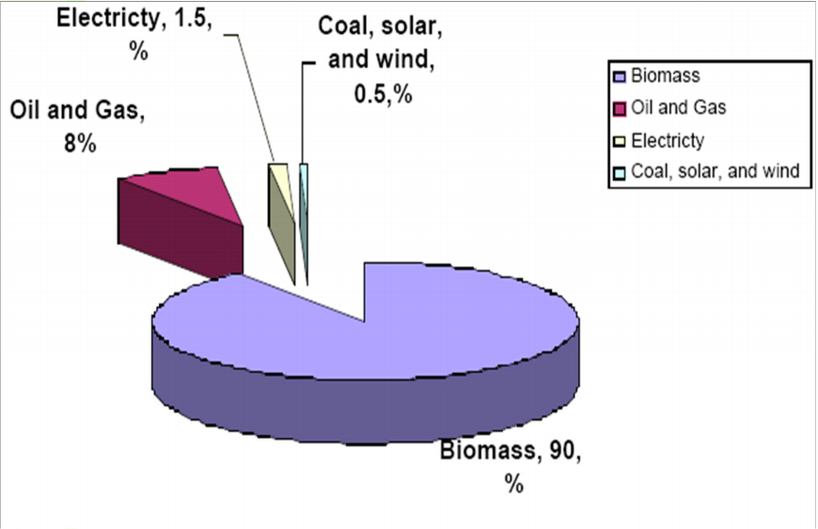

Figure 3: Energy Supply in Tanzania[21]

### Biomass

90% of the total primary energy supply in Tanzania comes frombiomass such as wood and charcoal. This is mainly because of the high cost of electricity, the lack of access to electricity, the abundance of natural trees & shrubbery in the environment and the nomadic lifestyle of the people of Tanzania [22]. According to a study run by Mwema Felix & Shabbir H. Gheewala, 80% of the Tanzanian population rely heavily on biomass to survive and meet their basic energy needs. As the population grows and people get poorer, the use of biomass resources increases but the amount of resources available in their environment decreases by a significant amount [23]. In Dar es Salaam in particular, around 75% of the energy used for cooking is from charcoal and wood while 2% is from electricity and around 40 % of the energy for lighting comes from wood and charcoal while 54% comes from electricity [24].

The commercialization of wood resources has been found to positively increase the economy of the Tanzanian people because it introduces labor and trade into the market [23]. However, around 100,000 hectares are deforested per year but only one fourth of that is reforested. In 2012, there were 32.6 million hectares of forest cover, which is 30% of what was available during 1990 [24]. This decrease in the available resources, will eventually catch up to the Tanzanian population and they will start to face a scarcity of resources.

The consumption of biomass for fuel also has health constraints that have ended up impacting a large section of the population of Dar es Salaam. In recent years, there have been multiple cases of carbon monoxide poisoning and particulate matter byproducts in the conversion of biomass into fuel. What makes this worse, is that most of the energy taken from biomass sources is used for cooking. This results in the breathing in of these nasty byproducts by the local population, which results in serious respiratory illnesses [24].

### Biofuels

Biofuels are an expensive alternative to petroleum because they consume agricultural goods and are not very cheap to produce. The main crops used for biofuel in Tanzania are sugarcane, jathropa & palm oil. Most of the biofuel production in Tanzania is subsidized by many different private investors and urban farmers [24].

There are various privately run companies that are generating their own electricity. Currently, there are plans in order to make ethanol for cooking, in order to replace traditional biomass fuels such as wood and charcoal[24]. There is also the potential to produce ethanol from cattle droppings, sisal waste, forest residues and crop residues [25].

### Solar

There is no significant installed solar electricity generation capacity within TANESCO or the Tanzanian Electrical Grid. TANESCO does not have the necessary capital to front the initial costs of producing or integrating PV farms in Tanzania. However, the World Bank has conducted studies and found that Tanzania has inland areas which have high potential for solar power generation [26]. Tanzania has areas with the capacity to produce around 6 kWh/m2, which is around the same amount of solar power generation potential as Spain, one of the world leaders in solar power generation [27]. Refer to Figure 4 below. Even though, TANESCO is not willing to invest resources to develop solar infrastructure, they are collaborating with private investors and NGO’s like the International Finance Corporation & the World Bank in order to promote the development of private solar infrastructure, that can generate electricity and sell it back to TANESCO.

In terms of consumer solar generation in Tanzania, there are many companies that are selling off-grid solar generation units to consumers. Many companies, like Mobisol & Off-Grid Electric, [28] have adopted the telecommunication industry’s business model and are leasing solar panel usage to consumers. This is a very attractive model for consumers, because they can choose when to use the electrical grid, if they are connected, or choose to rely on the solar panels when the grid is unreliable/expensive. The off-grid electric market has provided clean energy access to around 1 million consumers throughout all of Tanzania.

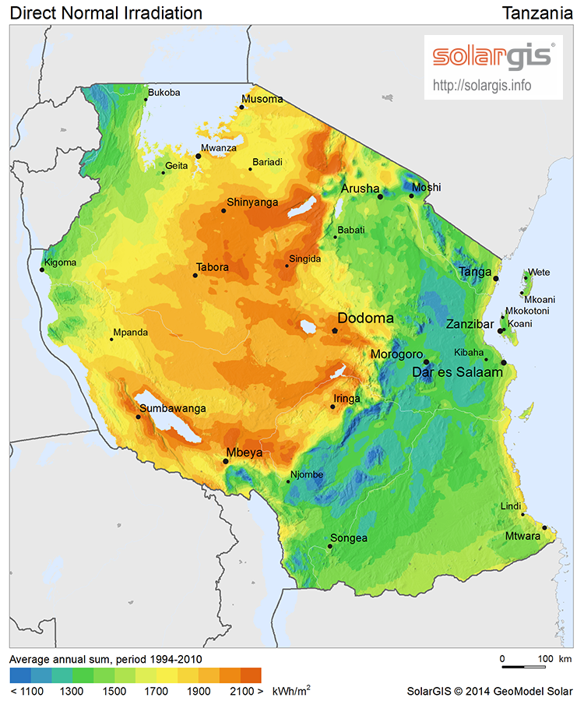

Figure 4: Solar resource intensity in Tanzania[29]

### Wind

TANESCO has no significant wind turbine generation or infrastructure in place as of yet [30]. However, the world bank has conducted studies and found that Tanzania has inland areas which have high potential for wind power generation [26]. Refer to Figure 5 below. Currently TANESCO is working in collaboration with the International Financial Group in order to integrate the Simbiya windfarm, which is expected to have a generation capacity of 100MW, into the existing electrical grid [31]. TANESCO hopes that this project and its potential success will pave the way for more substantive renewable energy generation projects throughout Tanzania.

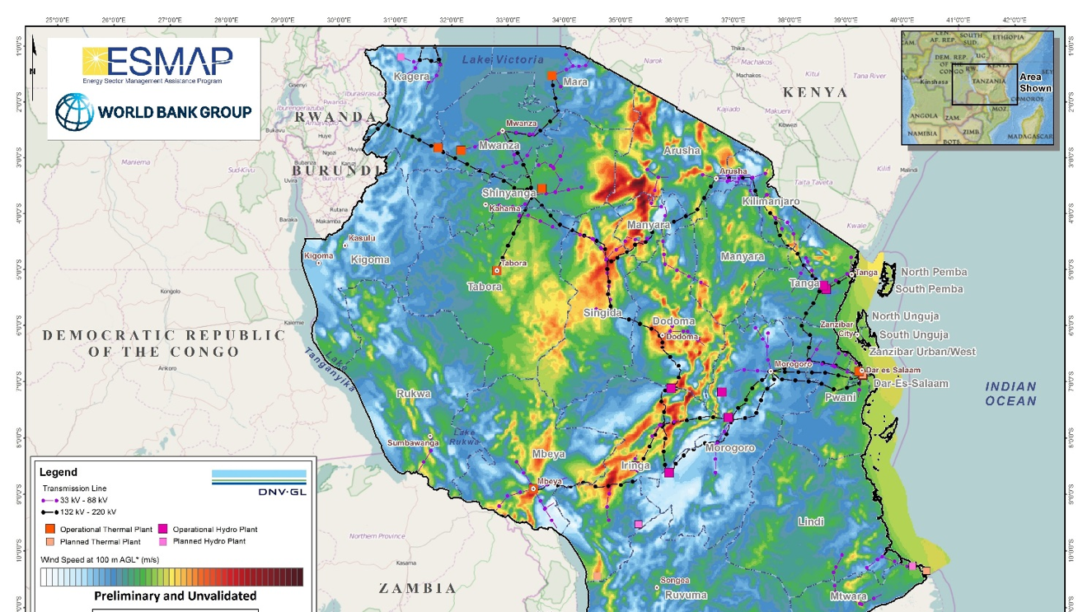

Figure 5: Wind resource intensity in Tanzania[29]

### Natural Gas

Natural Gas makes up approximately 45% of the total electricity generation in the country. There is a total of 58 trillion cubic tons of natural gas available in Tanzania [32]. This makes it be the easiest and cheapest way for TANESCO to provide energy to its consumers. Currently, there are two commercialized natural gas projects in Tanzania – the Songo Songo gas field (2004) and Mnazi Bay (2006) pictured in Figure (19) part of the gas from Songo Songo is allocated for use by Songas (a gas to power company) and the rest is marketed by Pan Africa Energy (the operators of the gas field) to TANESCO for power generation and 38 industrial customers in the Dar es Salaam area (cement, steel, textile). Songas also operates a 190 MW gas-fired power plant in Ubongo (a ward of Dar es Salaam). Mnazi Bay supplies 18MW from a gas-fired power plant belonging to TANESCO. There is a gas pipeline from Mnazi Bay to Dar es Salaam that is undergoing expansion to increase its service to residential and industrial customers in the capital.

### Hydropower

Around 37% of the total electricity generation is produced through hydropower. There is currently a total installed capacity of 567MW spread out throughout Tanzania [30]. While, Hydropower is currently one of the main generators of electricity in Tanzania, TANESCO is trying to shift from reliance on hydropower because of recent droughts that have been occurring for the past few years [32]. In December 2015, the hydropower plants were only operating at 20% of the total installed capacity. In order to compensate for this, TANESCO had to end up importing liquid fuel from neighboring countries and set up Emergency Power Projects (EPP) that could respond to the missing 400 MW of demand.

### Liquid Fuel & EPP’s

Dar es Salaam is a hub for the importing of liquid fuels and electricity generation from these fuels. The Nyakato Plant and the Zuzu Dodoma Diesel Plant are both stationed in Dar es Salaam and they have an installed electricity generation capacity of 6 MW and 63 MW [30]. There are also quite a few off-grid generation plants spread throughout Tanzania that provide around 25.5 MW of installed electricity generation capacity. which totals to around 7% of the total electricity capacity of TANESCO[30]. Liquid Fuel is usually used in times of drought or whenever there is a high spike in load, that the system cannot produce.

In 2008 & 2009 TANESCO faced a serious drought challenge and were forced to develop EPP’s in order to compensate for the loss in supply. The production and distribution of electricity through EPP’s is very expensive and it makes the price of electricity surge to 40¢/kwh, during times of drought [21]. Obviously, TANESCO is trying to develop sustainable and resilient power generation alternatives that can staunch the need for EPP’s.

**Transmission/ Distribution**

The electrical grid transmission and distribution of electricity through Tanzania is handled solely by TANESCO. The transmission lines comprise around 5816.17 km from the Iringa – Shinyanga region through the Makambako – Songea region. The total transmission line network has a total span of around 5816 km. However, only 48% of the current is electrified so they are conducting many projects to try to expand electricity access within the city and are conducting some projects to expand the grid to the rural areas.

One such project is the addition of 220kV transmission lines from Dar es Salaam through the Arusha region [33]. However, while the Tanzanian government is thinking of expanding its electrical grid to provide access to the rural areas of Tanzania, one of the main focuses of TANESCO is to support the production of SPP’s in the region to promote electricity access.

The maximum load experienced by the grid from January to June 2017 was around 1046 MW on February 14,2017 [33]. The total transmission and distribution losses in Tanzania are comparable to its neighbors but significantly higher than countries around the globe. TANESCO has reported losses of 6.12% from 2012-2017, with a 5.12 % loss from January-June 2017 [33]. This is very interesting because this directly conflicts with the 17% transmission loss that the World Bank reports [9]. Since the World Bank reports are usually more trusted than other sources, this shows under how much pressure TANESCO is in to perform well from foreign investors and government influence.



Figure 6: Transmission grid of Tanzania[21]

### Small Power Projects-Minigrid

In 2009, in the effort of decentralizing the energy grid and promoting entrepreneurship and private investment in the areas of solar & wind generation, the government of Tanzania approved the SPP framework. This basically entails that companies that are planning to generate around 0.1MW to 10MW through the use of solar PV, biomass/biofuel, wind & hydro are encouraged to create their own power generation and sell to TANESCO. The current amount of SPP’s in Tanzania are somewhere around 10 % of the total grid’s capacity for them [24].

While TANESCO is trying to foster entrepreneurial growth and foreign investment in this industry, it has not been very successful because there are several unappealing aspects to being an SPP in Tanzania. For example, SPP’s tariffs are determined by the avoided cost of TANESCO’s avoided costs, which might be annoying for developing firms because they might need extra revenue during the initial phases. Another drawback for many foreign investors is that the energy tariff is paid in the local currency which is constantly depreciating vs the US dollar which is mostly stable. The Tanzanian Shilling has depricated20 % from 2009-2015 [29]. In particular, renewable SPP’s like solar and wind, have a high barrier of entry for foreign investors and the low tariff’s and foreign currency depreciation do not entice them to invest in SPP’s in the Tanzanian energy market.

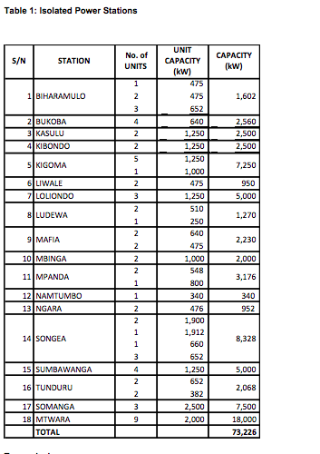

Table 1: Isolated power stations in Tanzania[24]

# Energy End Uses

Discussion in previous sections illustrates the economic, demographic, regulatory, and infrastructure challenges faced by the population of Dar es Salaam related to energy use. Consequentially, it should not be surprising that the per-capita annual energy use of the residents is a mere 40 GJ[1], as compared to 290 GJ for the United States [34]. Note that the Dar es Salaam per-capita energy use is significantly higher than that of Tanzania (21 GJ) [35], an indication of the energy access issues prevalent throughout rural Tanzania.

Energy use by sector is shown in Figure 6 below. The primary drivers of energy use in Dar es Salaam are residential consumption (dominated by biomass combustion for food preparation), local industry, and transportation, with other sectors contributing insignificant use.

Figure 7: Dar es Salaam Energy Use by Sector

The sections below provide a more detailed review of the various end-uses of energy. A prevalent theme which cuts across the sectors reviewed is the ingenuity and resilience of residents in the face of energy scarcity and poor infrastructure: from harvesting biomass for charcoal conversion, to backyard gardens and livestock; from informal industries that excel at repurposing and refurbishing, to microbuses overflowing with passengers and goods. The people of Dar es Salaam excel at making the most of the limited energy resources available to them.

## Transportation

The transport sector of Tanzania uses a large portion of the nation’s petroleum: 88% of all oil products in Tanzania [35] and roughly the same proportion in Dar es Salaam, which accounts for 42% and 35% of all the gasoline and diesel sold in Tanzania, respectively. Further, it is believed that almost half of the nation’s total road vehicles are present in Dar es Salaam [36, p. 1]. This study considers only energy consumed for only intra-city transportation; thus, transit which originates or terminates beyond the municipal boundary, such as transport by rail, plane, long-haul cargo truck or bus, and ship is disregarded. Further study of national and international travel from Dar es Salaam should begin with an analysis of Dar es Salaam International Airport; the city’s port and associated container terminal; and the railway lines, Tanzania Zambia Railway Authority (TAZARA) and Tanzania Railways Corporation (TRC) [36, p. 413].

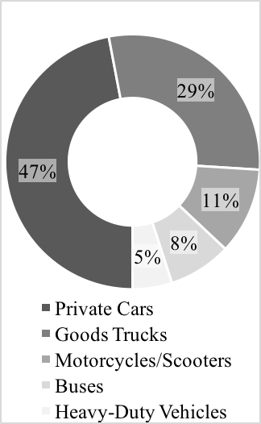

Figure : Dar es Salaam Road Vehicle Composition

The vehicle composition of Dar es Salaam is dominated by private cars and goods trucks, as shown in Figure 3 [36, p. 415]. Private cars are an inefficient mode of passenger transport in terms of energy, emissions, and congestion; thus, a shift to public transit or ride sharing methods would be desirable. In total, 45% of the vehicles imported to Tanzania are used or reconditioned. Surveys suggest that regular maintenance is cost prohibitive for many in Dar es Salaam, and between 57% and 89% of vehicle owners report their vehicles as “defective” [36, pp. 416–419]. The state of disrepair across the vehicle stock exacerbates energy waste, local air pollution, and greenhouse gas emissions.

The transportation network of Dar es Salaam consists of approximately 2,100 km of roads [37, p. 3] which are frequented by a mix of public and private transit modes. Local issues include safety and congestion issues, with average transit speeds of only 10 to 12 km/hr (6 to 7.5 mi/hr) due to overcrowding of roads [37, p. 7]. Public transportation systems in Tanzania, including those of Dar es Salaam, are unreliable, which incentivizes use of private transport for those who can afford it. Increases in use of private transport contribute to congestion of roads, driving unnecessary pollution and raises energy consumption. The Ministry of Energy and Minerals has identified five policy goals to promote energy efficiency and conservation within the transportation sector [38, p. 25]:

1. Increase use of alternative fuels (electricity, ethanol and compressed natural gas);
2. Shift private transit use to public transit;
3. Improve energy efficiency awareness;
4. Develop more efficient transit infrastructure; and
5. Improve regulations for efficient transportation equipment and systems.

This study includes a comparative analysis of the energy-intensity of the various forms of passenger transport, shown in Figure 3. Refer to Appendix A, Table 3 for detailed calculations by passenger transit mode. The results for car and daladalas are consistent with those identified in literature [36, p. 4], although slightly higher due to increasing congestion as population growth strains the existing infrastructure (literature review did not identify estimates for scooter or BRT).

### Private Transport

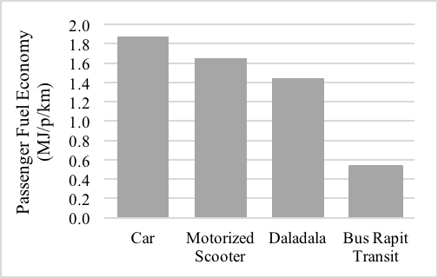

Figure : Passenger Fuel Economy by Mode

In Africa, private vehicle ownership is closely linked to income. Given the poverty rate in Dar es Salaam, it is not surprising then that only 7% of the population uses private motorized transport [4, p. 175]. Common modes of private transport are car and scooter, which are estimated to consume 1.9 MJ and 1.7 MJ per passenger mile, respectively. These modes are significantly less energy and space efficient and when compared with public transport.

### Public Transport

The primary form of public transportation in Dar es Salaam is a network of privately operated, publicly registered commuter busses, known as *daladalas*. The system of approximately 6,800 *daladalas* is renowned for its issues: no operating schedule, long wait times, overcrowding, traffic bottlenecking, gaps in service hours (especially during late hours), and dangerous operation on inadequate infrastructure [37, p. 3]. A survey of 10,000 local commuters found that average commute times are over three hours per day on the *daladalas* [37, p. 7]. Dar es Salaam is in the process of establishing a bus rapid transit (BRT) system with capacity for 495,000 passengers per day. The USD 350 million public private partnership system will be built in two phases, and is funded by the World Bank, AfDB, AGTF, and Government of Tanzania. It is designed to use cleaner fuels and reduce emissions of greenhouse gases [4, p. 211]. BRT systems are designed to operate like modern rail transportation, but can be accomplished at a fraction of the cost. Tactics employed to speed operations include dedicated bus lanes, high-capacity articulated buses, bus-level boarding platforms, and fare payment at stations instead of inside the bus. The buildout of the BRT system in Dar es Salaam includes a complete reconstruction of the major thoroughfares along which it runs, to include: four lanes of standard traffic (two inbound and two outbound), two dedicated bus lanes (one each way), sidewalks and bike lanes where possible, dividing medians, new bus stations, and two additional lanes for busses to overtake traffic at the stations. The busses will run in the middle of the transit corridor, and will be accessed by pedestrian overpasses [37, pp. 3–5].

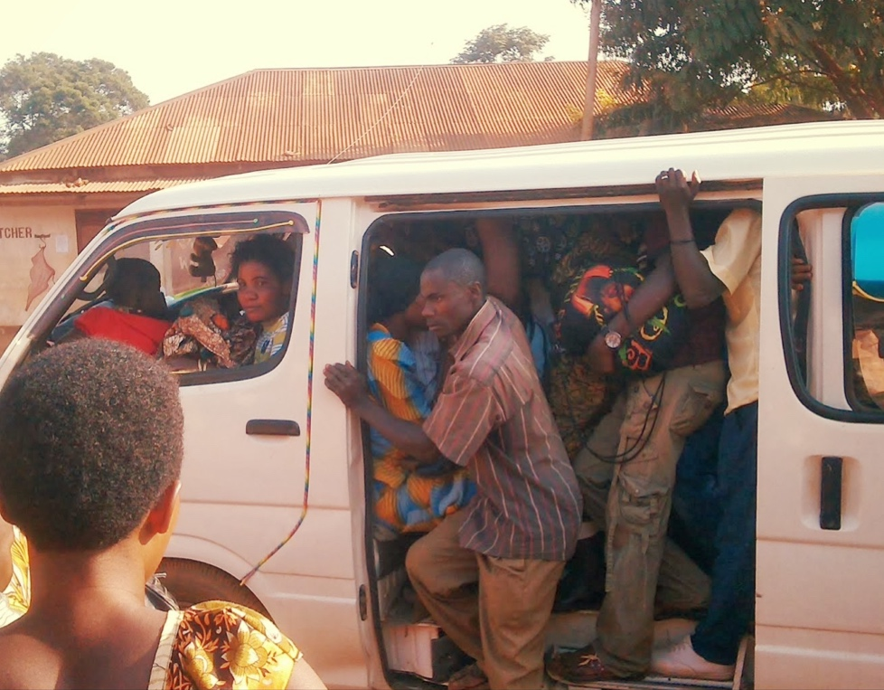

Figure : Tanzanian daladalas

Photo Credit: [Lab Rat in Tanzania](http://leenhome.blogspot.com/)

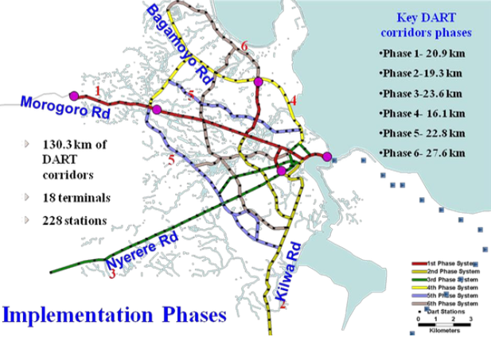

Figure : Dar BRT system plan

Source: African Development Bank

### Goods Transport

Dar es Salaam is home to a multitude of formal and informal industries, urban farms, and small businesses. For this reason, goods trucks comprise a large fraction of the intra-city transport, 29% of the total road vehicles. The majority of these (17% of the total road vehicles) are light-duty goods trucks for small loads [36, p. 415]. The same issues of congestion, poorly maintained and inefficient vehicles, and insufficient road infrastructure plague goods transport.

## Buildings

Building-related energy use the primary contributor to total energy consumption in Dar es Salaam. The city faces building-related energy issues consistent with those of Tanzania at large: low thermal performance of buildings, inefficient combustion of cooking fuels, wasteful heating and cooling systems, and below-average equipment efficiencies. The Ministry of Energy and Minerals has identified five policy goals to promote energy efficiency and conservation within Tanzanian buildings [4, p. 24]:

1. Integrate energy efficiency and renewable energy into housing policies and building codes;
2. Establish and promote minimum energy standards for appliances;
3. Improve awareness and raise capacity for energy efficiency
4. Promote energy audits for commercial buildings; and
5. Implement commercial building energy monitoring.

The building sector is comprised of residential, commercial and institutional, and industrial structures. Limited data are available regarding the quantity and composition of the structures in Dar es Salaam, especially non-residential. A 2007 survey of the housing stock in the Kinondonidistrict of the city shows that the typical home is modestly constructed with a cement floor (86%), concrete brick walls (82%), and corrugated iron roofs (96%) [39, p. 170]. A broad review of industry and economic literature, as well as examination of aerial imagery suggests that there is a significant number of warehouses, garages, and small factories in the industrial regions of the city. According to a recent report published by the World Bank Group, Tanzania does not have building energy codes to set minimum standards for the efficiency of new construction in either the residential or commercial sector [40, p. 36], a common practice among wealthier nations concerned with energy conservation.

### Food Preparation

The single largest source of energy use in Dar es Salaam is combustion of biomass (charcoal and firewood), with food preparation being the greatest end-use of this biomass. The last few decades have seen fluctuations between the proportion of charcoal and firewood used in Dar es Salaam, but together these fuels are the primary source in approximately 75% of the households [39][41]. Charcoal is a partially refined fuel, that (in Tanzania) is derived from wood; it is a more efficient, less expensive, and cleaner burning fuel than firewood. Other fuel sources for food preparation are kerosene, electricity, and gas; kerosene is the most common among these three [39][41]. Electricity is the lowest-cost option over time, but the upfront investment for a grid connection and an electric stove is prohibitive for most. Many households use two or more fuel sources, switching between them based upon fuel availability, pricing, weather conditions, and time availability (kerosene, for example, is often used for breakfast as it cooks meals faster) [41].

The growing population of Dar es Salaam, coupled with its heavy use of biomass fuel has resulted in excessive exploitation of woodlands in the surrounding region [39][42]. More fuel-efficient stoves as well as afforestation programs are necessary to combat the rapid deforestation of the Dar es Salaam region [41]. Other issues commonly associated with the use of open-fire biomass combustion in homes include indoor and local air pollution and health issues, such as acute respiratory infections (ARI). ARI is the leading cause of death of children under age five in developing countries [43].

### Lighting

Another significant source of building-related energy use in Dar es Salaam is lighting. One third to half of the population uses electricity for lighting; the remainder mostly use lamps or candles, with kerosene as the dominant fuel. A small fraction of the population has begun using solar-powered lighting, which is an attractive low-cost alternative to a grid connection fuel or regular purchase of fuel oil [39][41]. Kerosene lamps contribute significantly to indoor air pollution [41].

### Space Heating, Cooling, and Ventilation

Heating, ventilation, and air conditioning (HVAC) equipment is a major source of energy use in wealthy nations. This is rarely true in poorer nations, due to the high cost of infrastructure and energy relative to income. The climate of Dar es Salaam is hot and relatively humid; the city experienced 3,643 cooling degree days (base 70°F) and only 1 heating degree day (base 65°F) in the most recent 12-month period beginning October 2016 [44]. The most comparable U.S. cities would be Honolulu, HI (2,807 CDD, 0 HDD) and San Juan, Puerto Rico (4,123 CDD, 0 HDD). Despite the heat, aerial imagery and surveys of residential energy use do not indicate any HVAC equipment in use in homes in Dar es Salaam [39][41], however, it is plausible that this is not true for the very wealthy residents. Large commercial buildings, however, appear to be equipped with air conditioning and ventilation systems. Figure 6 [45] indicates the presence of a variety of chillers and direct expansion condensing units in one of the commercial districts of Dar es Salaam.

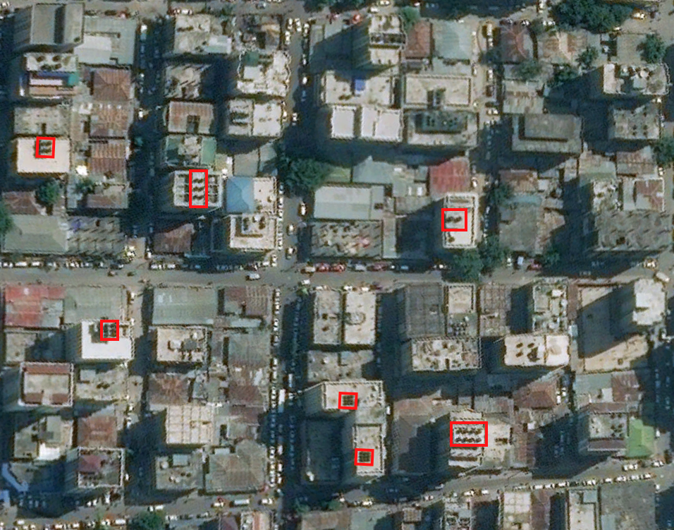

Figure : Dar es Salaam Commercial District

### Appliances & plug load

Electric devices constitute a very small portion of the energy us in Dar es Salaam. Electricity only accounts for 1% of the average Tunisian household’s energy use [35] and most households which are electrified use the electricity for only for lighting, although some also have electric cook stoves. Household surveys conducted in 1990 identified fans, radios, and electric kettles in some homes [41]. A detailed literature review did not uncover reliable information regarding the prevalence, composition, or energy use of appliances and plug load in Dar es Salaam or Tanzania.

## Industry and Manufacturing

Dar es Salaam is a major hub for industry and manufacturing within Tanzania. The industrial sector is a major consumer of energy in Tanzania: it is the sole consumer of Tanzania’s coal market, and a significant user of petroleum, electricity, and biomass [35]. It is also a source of massive energy waste, as industrial users have outdated and inefficient equipment and typically lack the awareness and expertise to pursue energy management practices. The Ministry of Energy and Minerals has identified seven policy goals to promote energy efficiency and conservation within Tanzanian industry [38, p. 23]:

1. Improve awareness and raise capacity for energy efficiency;
2. Advance energy management systems practices;
3. Mandate energy audits and address opportunities identified in the audits;
4. Establish energy advisory services;
5. Provide incentives for energy efficiency and conservation;
6. Benchmark energy uses according to international best practices; and
7. Implement time-of-use tariffs.

In Dar es Salaam, there are a variety of industries, often geographically co-located by industrial sector. These sectors include general manufacturing and processing industries, service industries (including garages and warehouses), wood products such as furniture manufacturing [37], and metallurgy (especially gold, which accounts for 15.5% of national exports [4, p. 351]).

## Agriculture

It is difficult to overstate the importance of urban agriculture in Dar es Salaam. Local food production provides a source of stability with manifold benefits – household nourishment, steady employment, income and accumulation of capital, urban food security – in an otherwise insecure time for many residents. The significance is underscored by the sheer magnitude of food produced locally: 60% of all eggs, 70% of all milk, and 90% of all leafy green vegetables consumed in Dar es Salaam [46]. The widespread nature of urban and peri-urban farming, however, does not come without a price. Farming is a primary cause of deforestation throughout Tanzania, and the forestland around Dar es Salaam has been greatly diminished as farmers seek to expand arable land [41].

### Crops

The growth of crops in the urban areas happens at multiple levels of production. First, many households contribute on a micro-scale through growth of crops in small plots around their homes. Such produce typically includes sweet potatoes, amaranth, pumpkin, and cow peas – all which are prized for their leafy greens. Next, officials and employees of the government are typically provided housing with more spacious yards and running water connections; residents in such housing will often grow expansive gardens and raise livestock there. The final scale of crop production includes traditional farms within the inner city and along the outskirts of Dar es Salaam [47]. Inner city farms tend to produce perishable produce such as leafy green vegetables, while their peri-urban counterparts grow crops which can withstand the longer journey into the city: tomatoes, eggplants, cucumbers, peppers, okra, [47] coconuts, cashew nuts, and cassava [48].

### Livestock

It is estimated that 74% of urban households in Dar es Salaam raise livestock [46]. Chicken farming, primarily for eggs, is prime among the various forms of urban agriculture practiced in Dar es Salaam. The low capital needed for startup coupled with steady demand for eggs makes it a viable business proposition [48]. Raising cattle for milk is another leading agricultural activity [46]. Livestock in Dar es Salaam are viewed as complimentary to vegetable gardening, as the manure is a key source of fertilizer and the same goods distribution network can be used for sale of produce and animal products [48].

# Conclusion

Dar es Salaam is a developing city that is currently only around 42% electrified [3] with serious electrical grid transmission losses and a very low population income. TANESCO and the Tanzanian government are currently trying to expand the electrification of Tanzania to around 75% by 2030 which is a very ambitious goal [49]. They have ramped up electrification rates in the urban areas from 18% to 32% in the last 3 years which is a very impressive feat considering the massive infrastructure construction lead times [29]. However, as TANESCO expands more and more they are going to have to deal with the increase in electricity tariff for consumers, high electricity theft problems, geographical constraints and high infrastructure construction entry barrier costs. In order to curb these costs and maintain affordability, TANESCO is seeking to pursue the development of natural gas and coal refineries throughout the country, as they have an abundant source of both (57 trillion cubic feet and 1.9 billion tons respectively) [50]. This would be a very cheap and relatively easy option for TANESCO to develop infrastructure. However, as Tanzania is getting funds from the World Bank and other they are hesitant to continue the development of coal and natural gas because they are wary that if their carbon emissions are high then they will retract their funding. As such, a possible route of development for TANESCO is to develop a hybrid renewable and non-renewable electricity generation plan that combines their massive amount of renewable energy potential (refer to Figure 13 below) with their enormous reserves of coal and natural gas. This could potentially attract interest foreign investors and create a more reliable and sustainable energy supply for Tanzania.

Figure 13 Renewable Energy Potential Renewable Energy Potential[29]

References

[1] World Bank Group, “ELECTRICITY ACCESS REPORT 2017.pdf.” 2017.

[2 “Doing Business in Tanzania - World Bank Group.” [Online]. Available: http://www.doingbusiness.org/data/exploreeconomies/tanzania#getting-electricity. [Accessed: 22-Oct-2017].

[3] World Bank Group, “Access to electricity, urban (% of urban population) | Data.” [Online]. Available: https://data.worldbank.org/indicator/EG.ELC.ACCS.UR.ZS?locations=MX. [Accessed: 31-Oct-2017].

[4] OECD, AfDB, and UNDP, *African Economic Outlook 2016*. OECD Publishing, 2016.

[5] F. Abebe, “informal settlement growth.pdf.” Mar-2011.

[6] Ministry Finance and Planning TZ, “NATIONAL FIVE YEAR DEVELOPMENT PLAN 2016/17 – 2020/21.” Jun-2016.

[7] “Tanesco collects Sh90m in power theft penalties.” [Online]. Available: null/News/Tanesco-collects-Sh90m-in-power-theft-penalties/1840340-3957668-6iysqp/index.html. [Accessed: 31-Oct-2017].

[8] “Electricity theft on an industrial scale | East & Horn Africa.” [Online]. Available: http://www.theafricareport.com/East-Horn-Africa/electricity-theft-on-an-industrial-scale.html. [Accessed: 31-Oct-2017].

[9] Donna Peng, *Sustainable electricity pricing for Tanzania.* 2016.

[10] P. Laude, “PROSPECTUS_TZ-_Report_v4.pdf.” Oct-2014.

[11] “Drivers and barriers to rural electrification in Tanzania and Mozambique – Grid-extension, off-grid, and renewable energy technologies.pdf.” .

[12] “Doing Business in Tanzania - World Bank Group.” [Online]. Available: http://www.doingbusiness.org/data/exploreeconomies/tanzania#getting-electricity. [Accessed: 22-Oct-2017].

[13] BNEF, “BNEF climatescope-2016-report-en.pdf.” 2016.

[14] “East Africa drought: Power cuts in Tanzania - BBC News.” [Online]. Available: http://www.bbc.com/news/world-africa-14192896. [Accessed: 31-Oct-2017].

[15] J. Kapika, “Eberhard-Power-sector_reform_and_regulation_in_Africa_Book.pdf.” 2013.

[16] D. Peng, “Peng-Poudineh-2016-Working-Paper.pdf,” Aug-2016. [Online]. Available: https://www.theigc.org/wp-content/uploads/2016/08/Peng-Poudineh-2016-Working-Paper.pdf. [Accessed: 14-Oct-2017].

[17] Yachiyo Engineering, “Power-System-Master-Plan-Dec.-2016.pdf.” 2016.

[18] S. designed and built by Hydrant (http://www.hydrant.co.uk), “Tanzania lays out big investments in power generation,” *Oxford Business Group*, 24-Jan-2017. [Online]. Available: http://www.oxfordbusinessgroup.com/news/tanzania-lays-out-big-investments-power-generation. [Accessed: 23-Oct-2017].

[19] C. Mysani, “Tanzania Power Sector.pdf,” *USEA*. [Online]. Available: https://www.usea.org/sites/default/files/event-/Tanzania%20Power%20Sector.pdf. [Accessed: 02-Nov-2017].

[20] G. Tanzanian, “Corporate Business Plan – 2016-17.pdf,” *ewura.go.tz*, Jun-2016. [Online]. Available: http://www.ewura.go.tz/wp-content/uploads/2016/11/Corporate%20Business%20Plan%20%E2%80%93%202016-17.pdf. [Accessed: 22-Oct-2017].

[21] “TanzaniaInvest | The N1 website to invest in Tanzania,” *TanzaniaInvest*. [Online]. Available: http://www.tanzaniainvest.com/. [Accessed: 05-Oct-2017].

[22] E. Suelle, “Biomass & Biofuels Tanzania,” 2009. [Online]. Available: http://pubs.iied.org/pdfs/12560IIED.pdf. [Accessed: 22-Oct-2017].

[23] “Tanzania Energy Situation - energypedia.info.” [Online]. Available: https://energypedia.info/wiki/Tanzania_Energy_Situation. [Accessed: 12-Oct-2017].

[24] “Power Africa.” [Online]. Available: https://www.usaid.gov/sites/default/files/documents/1860/Tanzania%20_IG_2015_05_03.pdf. [Accessed: 16-Oct-2017].

[25] “Tanzania: Solar and Wind Potential Could Help Meet Future Power Generation Goals,” *World Bank*. [Online]. Available: http://www.worldbank.org/en/news/feature/2015/06/09/tanzania-solar-and-wind-potential-could-help-meet-future-power-generation-goals. [Accessed: 27-Oct-2017].

[26] E. Nyari, “Tanzania Solar Need,” *ijete.org*. [Online]. Available: http://www.ijete.org/wp-content/uploads/2015/09/140268.pdf. [Accessed: 27-Oct-2017].

[27] C. Commons, “Off-Grid:Electric Brings Solar Power and American Entrepreneur to Tanzania,” Jun-2015. [Online]. Available: https://www.usaid.gov/news-information/frontlines/science-technology-innovation-and-partnerships/gridelectric-brings-solar. [Accessed: 27-Oct-2017].

[28] “TANESCO - Generation,” *TANESCO*, Jun-2017. [Online]. Available: http://www.tanesco.co.tz/index.php/about-us/functions/generation. [Accessed: 27-Oct-2017].

[29] “Tanzania: Singida Wind Farm planned for Q2 2017,” *ESI-Africa.com*. [Online]. Available: https://www.esi-africa.com/news/tanzania-singida-wind-farm-planned-for-q2-2017/. [Accessed: 27-Oct-2017].

[30] “As hydropower dries up, Tanzania moves toward fossil fuels,” *Reuters*, 29-Dec-2015.

[31] “2015-tanesco-presentation-tansania.pdf,” *Tanzania Electric Supply Company LTD*, 2015. [Online]. Available: https://www.giz.de/fachexpertise/downloads/2015-tanesco-presentation-tansania.pdf. [Accessed: 23-Oct-2017].

[32] “TANESCO - Transmission,” *TANESCO*, May-2017. [Online]. Available: http://www.tanesco.co.tz/index.php/about-us/functions/transmission. [Accessed: 22-Oct-2017].

[33] “Renewable Energy Potential – RECP,” *RECP*, Oct-2017. .

[34] International Energy Agency, “International Energy Agency, Statistics: United States.” [Online]. Available: https://www.iea.org/statistics/statisticssearch/report/?country=USA=&product=balances. [Accessed: 21-Oct-2017].

[35] International Energy Agency, “International Energy Agency, Statistics: Tanzania.” [Online]. Available: https://www.iea.org/statistics/statisticssearch/report/?year=2015&country=Tanzania&product=Indicators. [Accessed: 07-Oct-2017].

[36] L. Wilson and J. R. Gashaza, “Transport and vehicle characteristics in the city of Dar es Salaam, Tanzania,” *SATC 2004*, 2004.

[37] African Development Bank, “Dar es Salaam Bus Rapid Transit Project, Environmental and Social Impact Assessment Summary.”

[38] Tanzania Ministry of Energy and Minerals, “The Draft National Energy Policy 2015,” Jan-2015. [Online]. Available: https://mem.go.tz/wp-content/uploads/2015/02/NATIONAL-ENERGY-POLICY-2015-Feb-2015.pdf. [Accessed: 06-Oct-2017].

[39] M. J. Mbonile and J. Kivelia, “Population, environment and development in Kinondoni District, Dar es Salaam,” *Geogr. J.*, vol. 174, no. 2, pp. 169–175, 2008.

[40] World Bank Group, “Regulatory Indicators for Sustainable Energy: Tanzania.” 2016.

[41] M. Andersson and H. Holm, “The Energy Market in Dar-es-Salaam, Tanzania.” Swedish University of Agricultural Sciences, 1990.

[42] O. Hofstad, “Woodland deforestation by charcoal supply to Dar es Salaam,” *J. Environ. Econ. Manag.*, vol. 33, no. 1, pp. 17–32, 1997.

[43] A. Krishnan *et al.*, “Epidemiology of acute respiratory infections in children - preliminary results of a cohort in a rural north Indian community,” *BMC Infect. Dis.*, vol. 15, no. 1, Dec. 2015.

[44] BizEE Software, “Heating & Cooling Degree Days.” [Online]. Available: http://www.degreedays.net/. [Accessed: 05-Oct-2017].

[45] Apple Inc., *Satellite Imagery of Dar es Salaam*. Apple Inc., 2017.

[46] A. Halloran and J. Magid, “Planning the unplanned: incorporating agriculture as an urban land use into the Dar es Salaam master plan and beyond,” *Environ. Urban.*, vol. 25, no. 2, pp. 541–558, Oct. 2013.

[47] P. Jacobi and J. Amend, “Vegetable cultivation in Dar es Salaam,” *Agric. Rural Dev.*, vol. 4, no. 2, pp. 52–54, 1997.

[48] A. Lupala and V. Kreibich, “A case study from Dar Es Salaam: Urban agriculture – a key to food security?,” *Rural*, vol. 21, no. 21, pp. 19–21, Jan. 2008.

[49]“Rural Electrification,” *TanzaniaInvest*, 16-Oct-2017. .

[50] “Coal,” *TanzaniaInvest*, 09-Oct-2017. .

[51] “tanzania-gas.gif (777×437),” *Tanzania Invest*, Oct-2017. [Online]. Available: http://www.tanzaniainvest.com/wp-content/uploads/2016/08/tanzania-gas.gif. [Accessed: 03-Nov-2017].

Appendix A: Supplemental Data and Energy Calculations

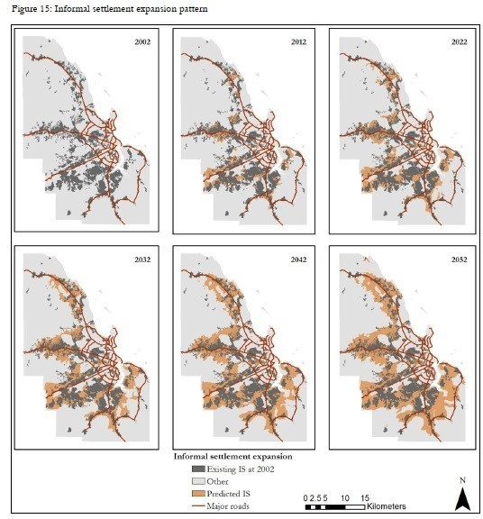

Figure 14: Informal Settlement Growth[5]

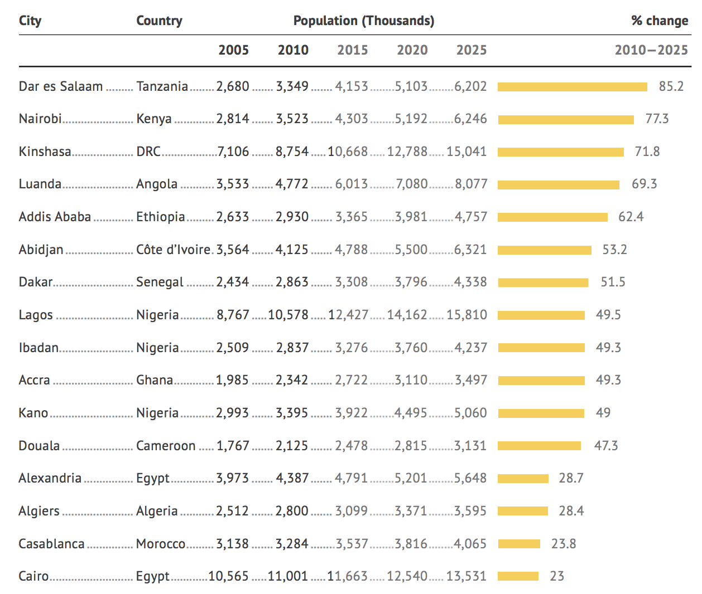

Figure 15: African Development Bank – Tracking Africa’s Progress in pictures [2, 9]



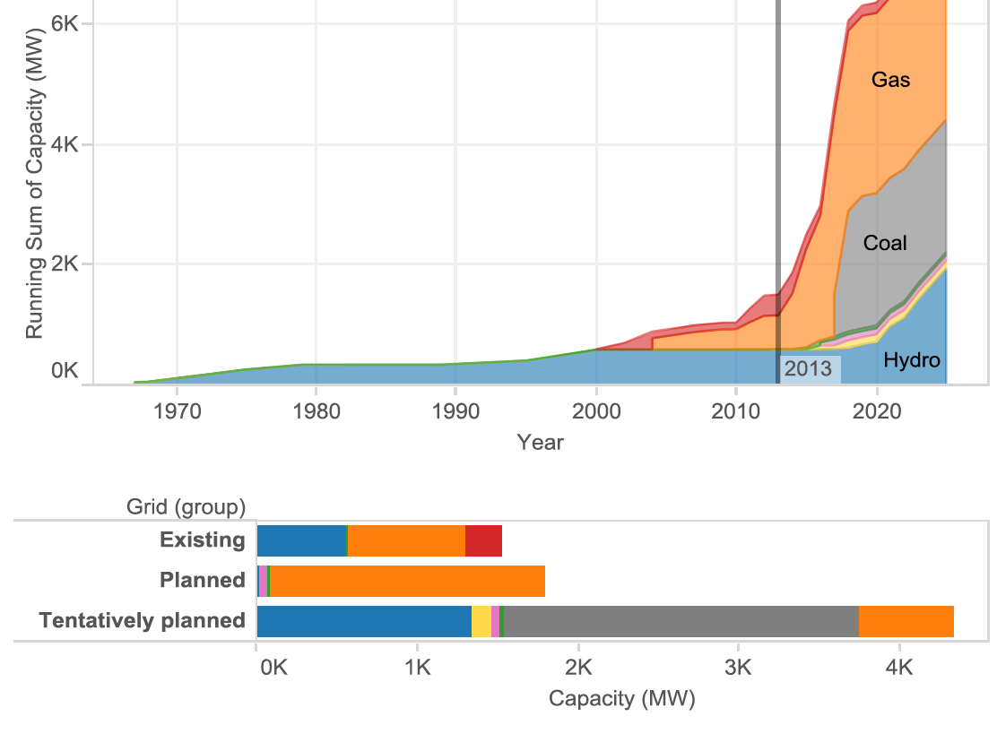

Figure 16 Peng, Sustainable Electricity Pricing for Tanzania, Oxford Institute for Energy Studies. 2016

Figure 17 Net Generation current and forecast [2]



Figure 18: Cost of Doing Business - World Bank. Methodology detailed [here](http://www.doingbusiness.org/Methodology/getting-electricity#Cost (% of income per capita)) indicates these figures refer to the economy’s “largest business city”



Table 2: End-use energy consumption data for Tanzania [35] and Dar es Salaam



Table 3: Energy intensity of transportation employed in Dar es Salaam, by transit mode

 Figure 19 Tanzania Natural Gas Plants[51]

1. Refer to Appendix A, Table 2: End-use energy consumption data for Tanzania [29] and Dar es Salaam for detailed calculations.